ELEC 4806/5806 Introduction to Deep Learning and PyTorch

**Lab 2 Intro to Neural Networks**

1. **Experiment goal:**

* Understand the structure of neural networks.
* Master the use of hyperparameters.
* Master the basic process of using PyTorch to implement deep learning.

1. **Introduction:**

In this lab, you will use multiple fully connected layers to build a neural network for image classification tasks. You will use the CIFA-10 dataset. It consists of 60000 **32x32 color images** in 10 classes, with 6000 images per class. There are 50000 training images and 10000 test images.

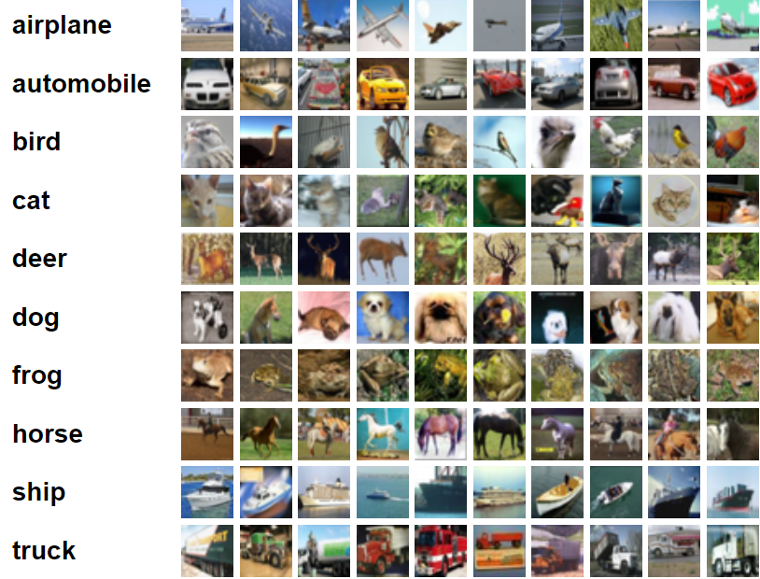

Please refer to the MNIST code example in Lecture6's note. But you need to pay attention to the following:

* **The minimum requirement for model performance is that the test accuracy is greater than 55.5%**
* Please use the following code to load/download the CIFA-10 dataset

train_loader = torch.utils.data.DataLoader(

    datasets.CIFAR10('../data', train=True, download=True,

                   transform=transforms.Compose([transforms.ToTensor(),transforms.Normalize((0.5,0.5,0.5),(0.5,0.5,0.5))])

                   ), batch_size=batch_size, shuffle=True)

test_loader = torch.utils.data.DataLoader(

    datasets.CIFAR10('../data', train=False,

                   transform=transforms.Compose([transforms.ToTensor(),transforms.Normalize((0.5,0.5,0.5),(0.5,0.5,0.5))])

                  ),batch_size=batch_size, shuffle=False)

* The MNIST contains a set of grayscale images, while the data of CIFA-10 are all color images(3 channels). Therefore, the number of neurons in the input layer will be different from the MNIST example.
* To achieve good performance, you can consider changing the structure of the network, such as changing the number of hidden layers or the number of neurons in each layer. You can also change the hyperparameters such as learning rate, batch size, epoch and so on. You need to keep trying to find a relatively good combination. Please be patient during this process. This is the most basic requirement for engaging in deep learning work.
* Since the image data in this lab are all color images, you also need to modify some other codes, such as the “**plot_image**” function, etc.
* Please use the MNIST sample code in "**Lecture6 note.ipnb**" as a template. **Plagiarizing code directly from other websites is not allowed**. At the same time, methods to improve model performance **not mentioned in Lecture6 are not allowed to be used**. The purpose of this is to prevent plagiarism.
* Please try to use Google Colab to complete this Lab. Because without GPU, the training process may take a very long time.

**Submission requirements (all team members need to submit):**

1. Please submit the **.ipynb file** and make sure the TA or the instructor can easily run your code. If you use google colab, you can download the .ipynb file by clicking “File🡪Download🡪Download .ipynb”. **Please include the names of all team members in the file name**.
2. Please submit a **pdf version** as well. You can use this website (<https://htmtopdf.herokuapp.com/ipynbviewer/> ) to convert your .ipynb file to pdf.
3. Please **record a video** to demo your work. In the video, **please indicate where you have changed the code and state the reason for the change.** **In addition, please describe in detail the process of modifying the model, adjusting the parameters, the problems encountered, etc.** And all team members must participate in the recording. If the team members cooperate remotely, they can submit multiple videos.
4. **When you are recording a video, if you just read the comments you wrote in the code, or read according to a script, then you will not be able to prove that the work was done independently by you. Therefore, the lab will be judged as plagiarism.**